ASSIGNMENT-3
Basic and conditional select statement on employee database
1. Display all the employee’s information whose job is Clerk.
A: SELECT * FROM emp WHERE job = 'CLERK';
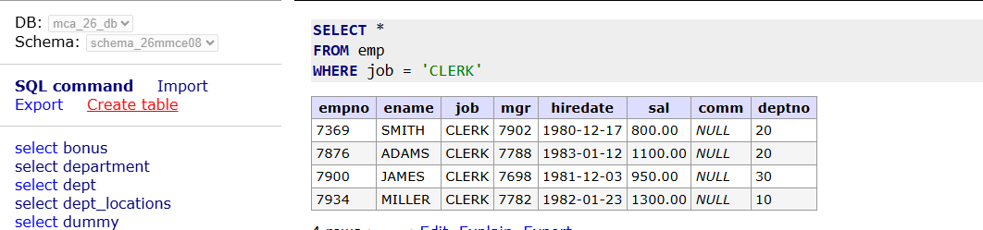
2. Display all the employee’s information whose employee number is 7788.
A: SELECT * FROM emp WHERE empno=7788;
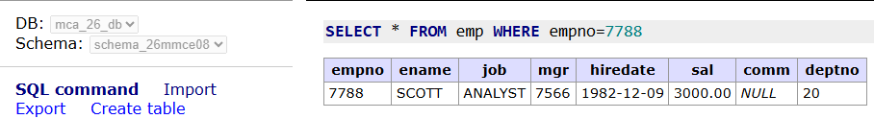
3. Display all the employee’s information whose commission is greater than his salary.
A: SELECT * FROM emp WHERE comm > sal;
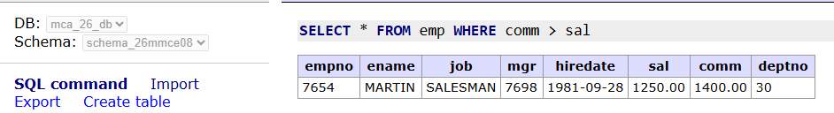
4. Display all the employee’s information those who are drawing a salary between1000and 2700.
A: SELECT * FROM emp WHERE sal BETWEEN 1000 AND 2700;
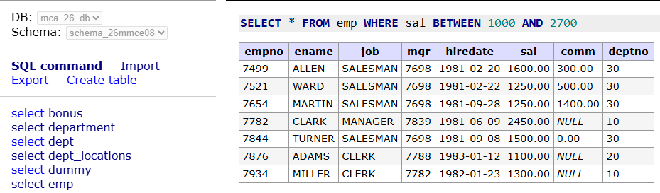
5. Display all the employee’s information whose employee number falls within acertainlist.
A: SELECT * FROM emp WHERE empno IN (7369, 7566, 7788, 7902);
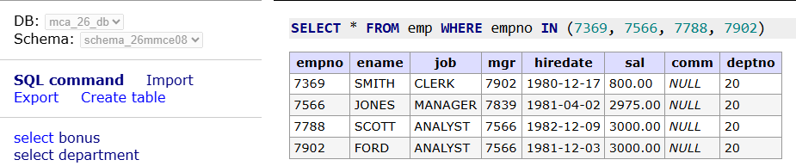
6. Display all the employee’s information those whose commission is not known.
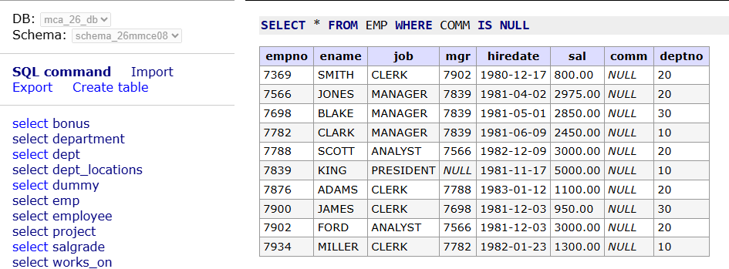
A: SELECT * FROM EMP WHERE COMM IS NULL;

7. Display all the employee’s information whose employee name starts with an alphabet 'S'.
A: SELECT * FROM EMP WHERE ENAME LIKE 'S%';
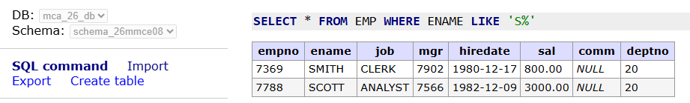
8. Display all the employee’s information whose employee name's third alphabet is 'O'.
A: SELECT * FROM EMP WHERE ENAME LIKE '__O%’;
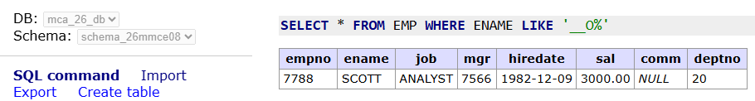
9. Display all the employee’s information whose employee name is of four characters only.
A: SELECT * FROM EMP WHERE ENAME LIKE '____';
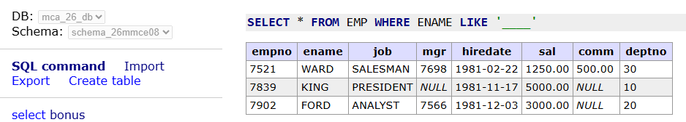
10. Display all the employee’s information whose job is like "MANAGER".
A: SELECT * FROM EMP WHERE JOB LIKE 'MANAGER';
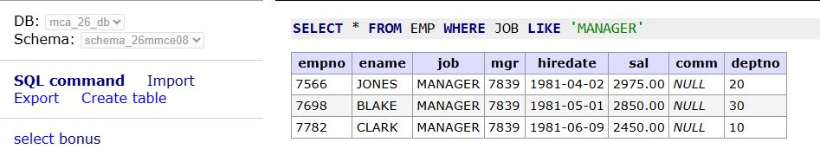
11. From Q.No. 4 to Q.No. 10, write the queries using in negative sense.
- Display all the employee’s information those who are drawing a salary not between 1000 and 2700.
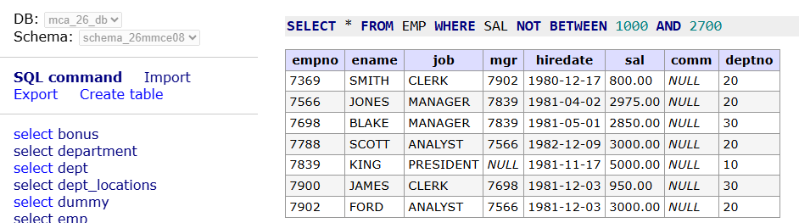
A: SELECT * FROM EMP WHERE SAL NOT BETWEEN 1000 AND 2700;

- Display all the employee’s information whose employee number not falls within a certain list.
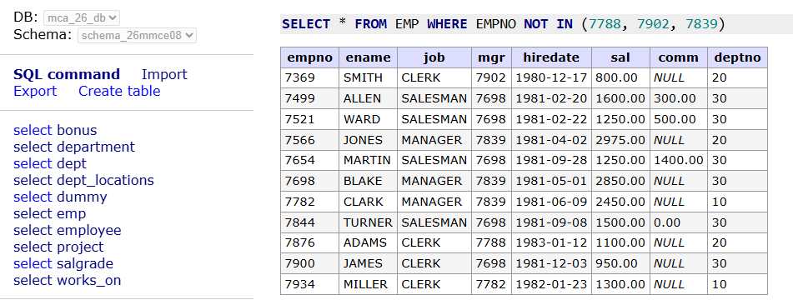
A: SELECT * FROM EMP WHERE EMPNO NOT IN (7788, 7902, 7839);

- Display all the employee’s information those whose commission is known.
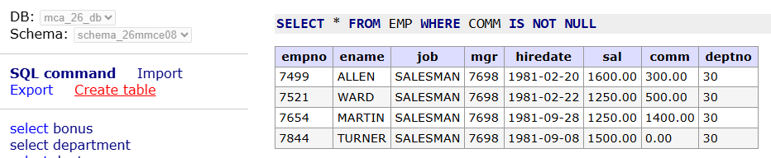
A: SELECT * FROM EMP WHERE COMM IS NOT NULL;

- Display all the employee’s information whose employee name not starts with an alphabet 'S'.
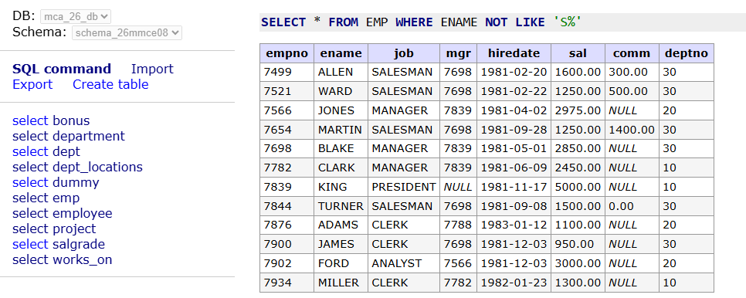
A: SELECT * FROM EMP WHERE ENAME NOT LIKE 'S%';

- Display all the employee’s information whose employee name's third alphabet is 'O'.
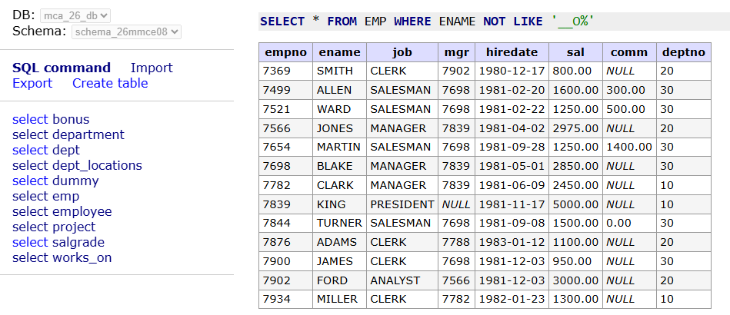
A: SELECT * FROM EMP WHERE ENAME NOT LIKE '__O%';

- Display all the employee’s information whose employee name is of four characters only.
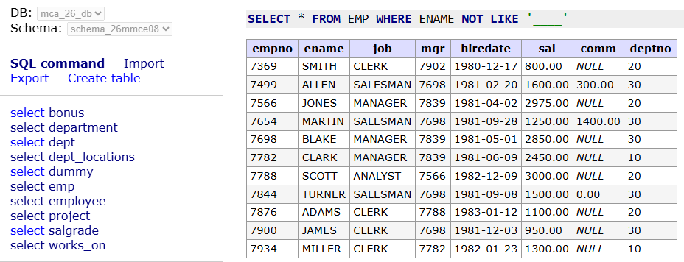
A: SELECT * FROM EMP WHERE ENAME NOT LIKE '____';

- Display all the employee’s information whose job is NOT like "MANAGER".
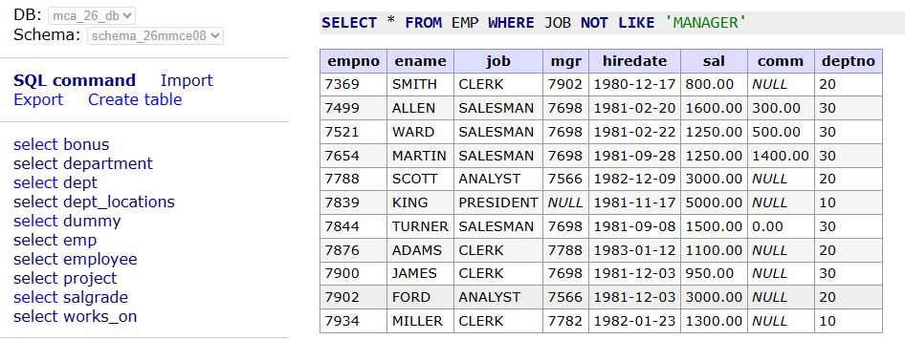
A: SELECT * FROM EMP WHERE JOB NOT LIKE 'MANAGER';

12. Display the sum of salary and commission for each employee.
A: SELECT ENAME, SAL + COMM AS TOTAL FROM EMP;
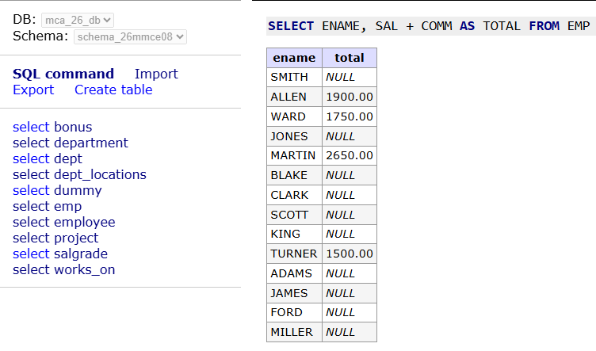
13. Display the sum of salary and commission for each employee by replacing commission with 100 for employees whose commission is not known or commissionis 0.
A: SELECT ENAME, SAL + COALESCE(NULLIF(COMM, 0), 100) AS TOTAL FROM EMP;
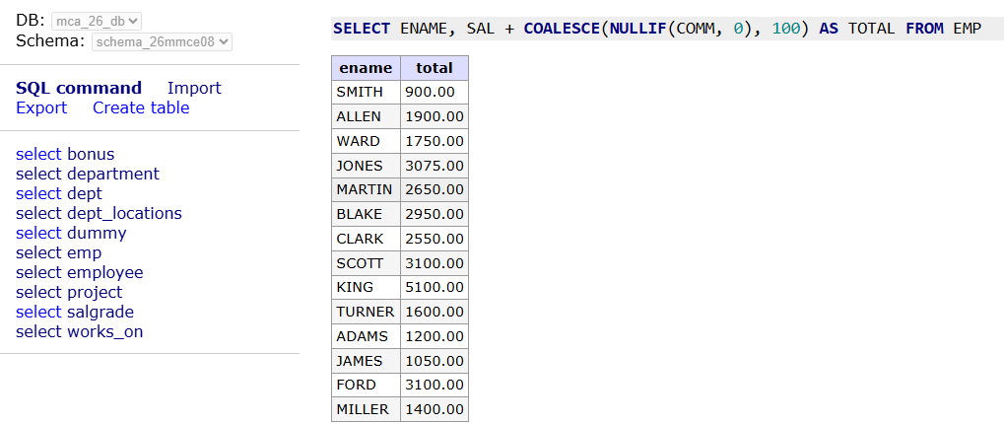
14. Display each employee's name, annual remuneration by giving a suitable alas for annual remuneration.
A: SELECT ENAME, (SAL + COALESCE(COMM, 0)) * 12 AS ANNUAL_REMUNERATION FROM EM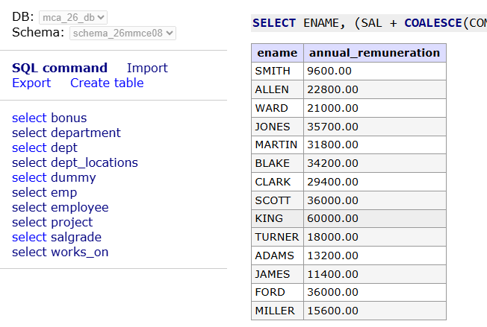

15. Display all the employee’s information whose salary is greater than 2000 and job is according to your choice.
A: SELECT * FROM EMP WHERE SAL > 2000 AND JOB = 'MANAGER';
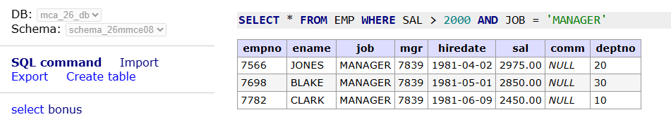
16. Display all the employee’s information whose salary is greater than 3000 or job is according to your choice.
A: SELECT * FROM EMP WHERE SAL > 3000 OR JOB = 'MANAGER';
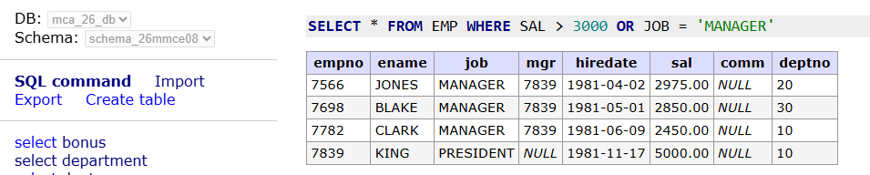
17. Display all the employees who are working under department 20 and not drawing a salary greater than 2000.
A: SELECT * FROM EMP WHERE deptno = 20 AND NOT sal > 2000;
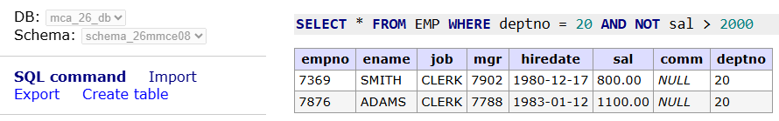
18. Display all the employees who are drawing a salary greater than 2000 and whose job is either manager or job of your choice.
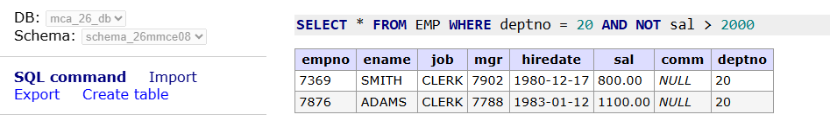
A: SELECT * FROM EMP WHERE SAL > 2000 AND JOB IN ('MANAGER', 'CLERK');

19. Display the names like WARD, FORD from EMP table using pattern matching.
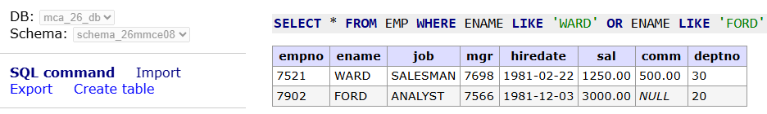
A: SELECT * FROM EMP WHERE ENAME LIKE 'WARD' OR ENAME LIKE 'FORD';

20. Write a query using a pattern matching to display the names like SMITH_CLERK, ADAMS_CLERK from EMP table. HINT: USE CONCATENATION and LIKE Operator.
A: SELECT ENAME || '_CLERK' AS CLERK_NAMES FROM EMP WHERE JOB = 'CLERK';
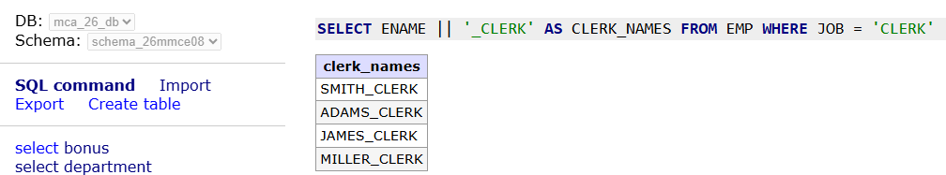

21. Write a query using a pattern matching to display the names like %ALLEN_SALESMAN, %ADAMS_CLERK from EMP table. HINT: USECONCATENATION and LIKE Operator.
A: SELECT '%' || ENAME || '_' || JOB AS FORMATTED_NAME FROM EMP WHERE '%' || ENAME || '_' || JOB LIKE '\%%';
